Second Salamanca Summer International Course on Advanced Biophysics and Structural Biology

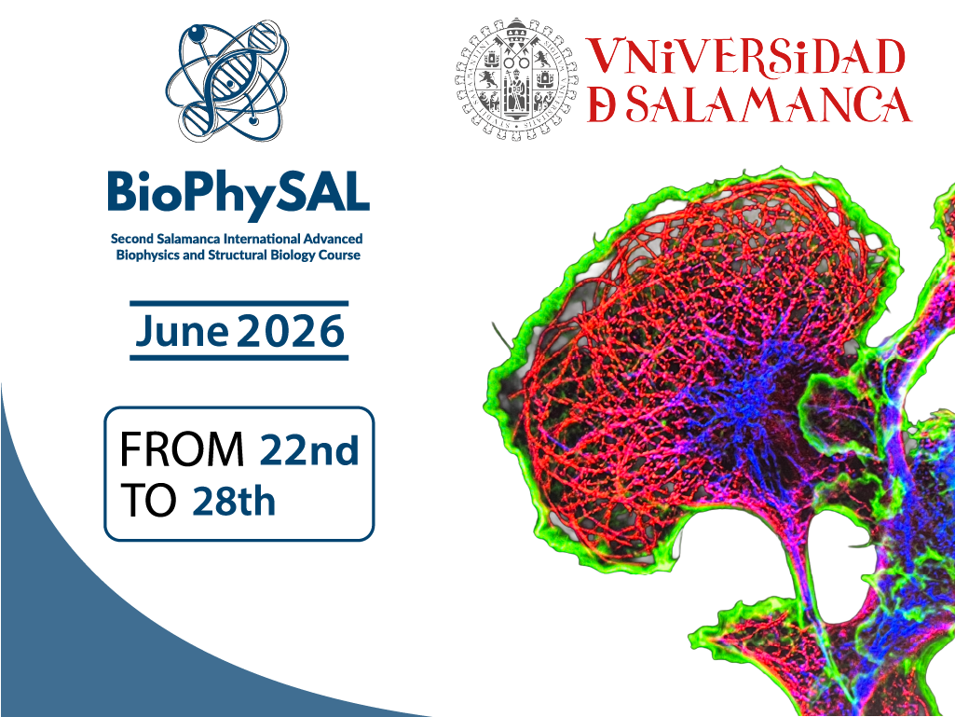

The 2nd “Salamanca Summer International Course on Advanced Biophysics and Structural Biology” (https://biophysal.org/) will be held at the University of Salamanca, one of the world oldest universities (the third oldest, after Bologna and Oxford), and located in World Heritage city of Salamanca. The course is organized by Profs. Carlos Bustamante and Eva Nogales from the University of California, Berkeley.
The 6-day course (June 22 – June 28) will cover single molecule studies and biological imaging at the molecular and cellular levels and will offer both lectures and hands-on components. The course includes a one-day symposium on “Advanced Structural and Molecular Biology” open to the scientific community.

The course will be imparted by:
- Carlos Bustamante (University of California, Berkeley, USA)
- Eva Nogales (University of California, Berkeley, USA)
- José María Valpuesta (National Center for Biotechnology, Madrid, Spain)
- Elizabeth Villa (University of California, San Diego, USA)
- Taek Jip Ha (Boston Children’s Hospital, Boston, USA)
- Ibrahim Cissé (Max Planck Institute of Immunobiology and Epigenetics, Freiburg, Germany)
- Fernando Moreno Herrero (National Center for Biotecnology, Madrid, Spain)
- Félix Ritort (Institute of Nanoscience and Nanotechnology, Universidad de Barcelona, Spain)
- Borja Ibarra (IMDEA Nanoscience, Madrid, Spain)
- Miguel Vicente Manzanares (Cancer Research Institute, Salamanca, Spain)
The course will be open to 25 students of any nationality. The registration fee is 150 €, which covers the course and the lodging. A limited number of travel grants will be available.
Registration will be open from December 9, 2025 to January 20, 2026. Applications should be submitted using the following form:
https://forms.gle/LDYbEHs3PrFxrqAa9

For further information, please visit: https://biophysal.org/
Contact: Fundación General de la Universidad de Salamanca, fgu@usal.es

